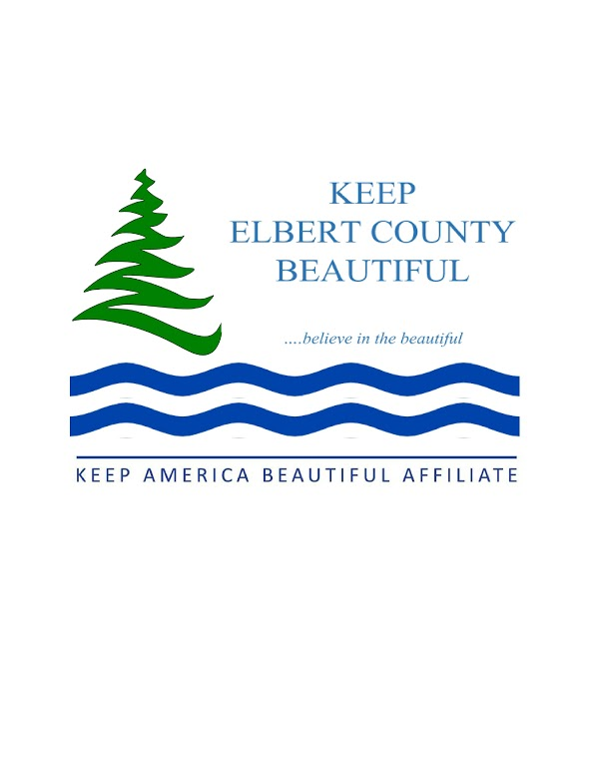

THANK YOU!!!

KEEP ELBERT COUNTY BEAUTIFUL 2026
I would like to make an additional donation of $___________. This money is to be used for-
____Scholarships/Educational items
____Beautification projects
____Littering projects
____Shredding costs at Recycling Events

Please check the Membership level desired:
___ Student: $10.00
___ Individual: $25. 00
___ Couple: $35.00
___ Business: $50.00
___ Individual Life Member: $250.00
___ Business Life Member: $500.00

Include a check for the appropriate amount of the membership and any other donations, payable to
KEEP ELBERT COUNTY BEAUTIFUL
PO BOX 6339
ELBERTON, GA 30635

Name:________________________________________________________________________

Contact Name (if membership is a business):_________________________________________

Address: ______________________________________________________________________

City: _____________________________________State: _______ ZIP Code: ______________

Phone Number: ________________________________________________________________

Email address: __________________________________________________________________

(This will be used to send the newsletter and information – it will not be shared – and you will be “blind copied” on all emails.)

____ Yes, I am interested in volunteering. _____Yes, I would like to attend a KECB meeting.
All memberships include a 2026 window decal, flyers of Public Recycling and Household Waste Disposal Options in Elbert County, Highlights of 2025, seed paper for planting and dates for our regularly scheduled meetings and recycling events, inclusion on the KECB mailing list, a copy of our newsletters (emailed or mailed) and a receipt letter for tax purposes.

