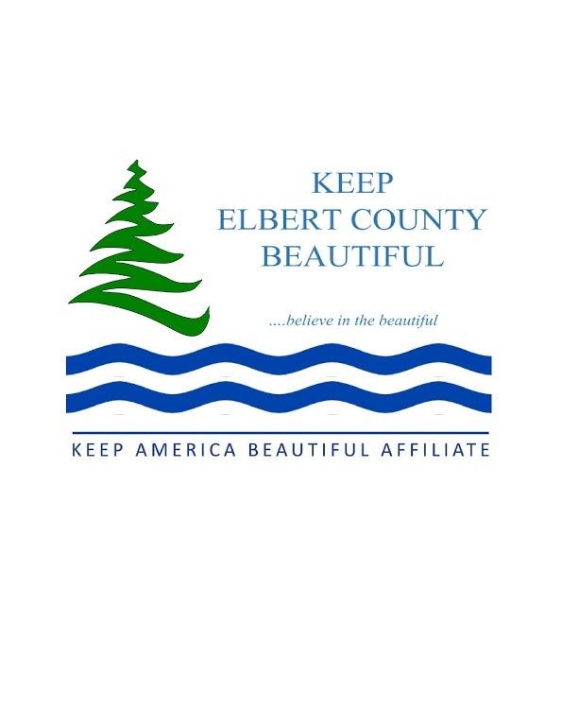
KECB Newsletter-August, 2026

Litter – July was another quiet month as far as litter pickups. It is just too hot unless you can convince volunteers to go out at 7:00 AM or earlier! Evidently, 6 JROTC members decided that 6:30 was okay because they surprised Meredith White, Director of the Chamber of Commerce, who scheduled a clean up for 7:00 AM at the Granite Bowl, after the fireworks on July 18th! Small pieces of paper are what is left and thank goodness they didn’t drift down onto the field like they did last year. By 8:30 AM everything was cleaned up thanks to these young people. Also in July, Donna, a former Board member, picked up 6 lbs. of litter on Poplar Springs Rd and the Blight Bandits found another 30 lbs. on Clarke Rd in Bowman.
Beautification- Several of us met with GA DOT at the 17/72 intersection about visibility and were given a list of items that needed to be cut back. Bill, one of our Board members has started on this work. Please remember to heed the speed limits at this intersection.
Membership- We have 90 members at this time.
Education- School has started again and we look forward to partnering with 4H ELEVATE, BETA clubs (ECMS and ECCHS) and JROTC. We would love to partner with other school groups. We are available to help with lessons concerning the environment at any age level. Let us know what you are thinking of.
Other--Are you looking for a challenging part-time position with flexible hours? The Executive Director job for KECB is available. The job description is on our website or you can request one by calling or emailing us.

Coming up in August we have- Welcome to any and all volunteers! -call (706-567-0481) or email (kecbeautiful@gmail.com) us to find out how you can be involved.
August 11-KECB monthly meeting at 5:30, in our office. Come and find out what we do.

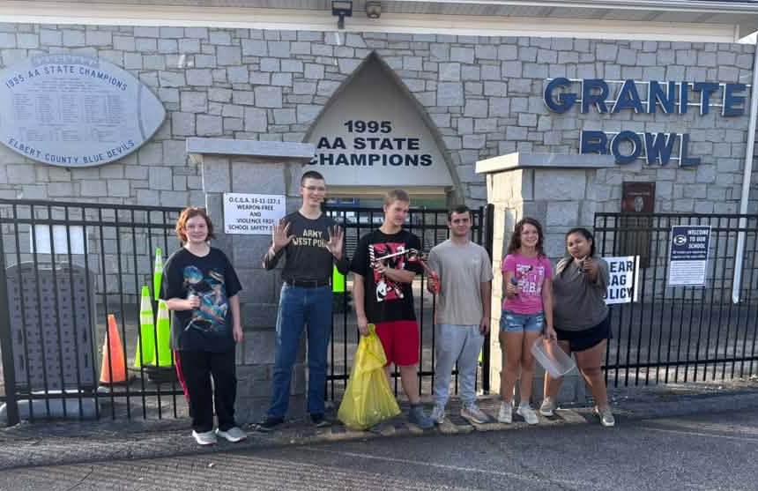
Thanks to JROTC members who cleaned up the Granite Bowl 7/19/26

